Encapsulation is not just hiding data!
Let's first look at what is generally believed as Encapsulation?
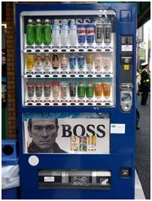
Lets take an example of the coffee vending machine.
How does it work?
You dropped in the coin, and the coffee came out of the machine in a beautiful coffee cup. So, why didn't you see how the where the coffee beans, how it is prepared? You really don't know (unless you are the one who designed the machine ;-)) how things are made inside the machine, but finally you get a coffee!!
This is an Encapsulation? So, here what is actually hidden? The Coffee beans? No, the way how the coffee prepared is hidden.
So, Encapsulation is hiding of process; hence you hide the data. Not the vice versa.
From the definition, Encapsulation is "Information Hiding", the information is how something is happening inside an object? It's just a mere data hiding concept (though it includes data hiding).
So, when you model this coffee vending machine, you don't want to show out the way how a coffee is made. Isn't it? So, you don't want to show where the coffee beans, milk and the sugar are. Right?
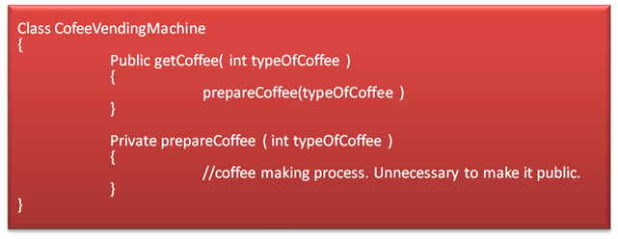
So, in the CofeeVendingMachine class, prepareCoffee() is hidden and getCoffee() is made public, so that you will be able to send a request to the machine.
Since you have hidden the process, you don't have any need to show how the coffee & milk are mixed and how it's been brewed. If you need a stylish design, even you can show that.
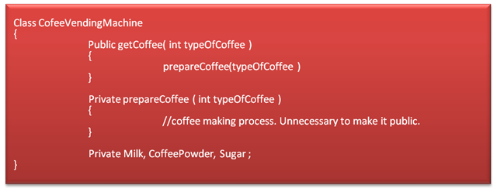
The Coffee Vending Machine encapsulates the internal process and the ingredients (data) used in the process.
Object Oriented Languages provides encapsulation via modifiers such as "private", "protected". Sometimes, volatile and transient also acts as encapsulating modifiers, but they are language specifics.

